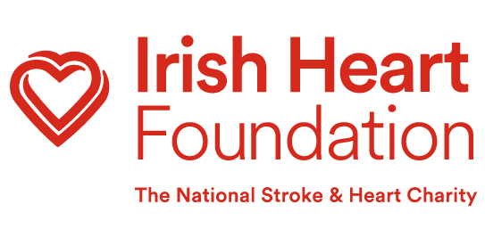
The Irish Heart Foundation’s Heart Failure Service is a community support service for Heart Failure patients across the country. We contact these patients via phone and inform them about the supports and services that we can provide to support them to live well post diagnosis.

These services and supports include Counselling, Peer-to-peer support, Quarterly Newsletter, Zoom information sessions, Heart Failure podcast, Nurse Support Line, Heart Failure pack, short-term programmes and ‘Heart Support Network’ Facebook Group.

Heart Failure Service Consent Referral Form
To be sent to heartfailure@irishheart.ie

Name of person being referred into the service:

DOB:

Email:

Phone:

Address:

Eircode:

NOK/Emergency contact details (name and number):

CHO (HSE Community Healthcare Organisation) area (if known):

Date/Year of Heart Failure diagnosis:

Other medical conditions (if relevant):

Any communication/language barriers?

Any mobility issues?

Comments/Notes:

Referrer Information

Name:
Role:
Contact Information:
Hospital/Heart Failure clinic/Self-Management hub:

Consent

Is your Patient aware that they have been diagnosed with Heart Failure?

Yes No

Have you discussed the diagnosis of Heart Failure with your Patient?

Yes No

Please confirm that your Patient is happy for us to contact them, and they have verbally consented to this referral:

Client and/or Next of Kin

Fair Processing Notice: By providing this verbal consent, you agree to the HSE sharing your contact details with the Irish Heart Foundation to be involved in the IHF Heart Failure Support Service. The IHF will store your data on their secure systems, in line with the GDPR, for 5 years and will not share it with any other parties. If you have any queries on this, please contact heartfailure@irishheart.ie

