Dear Student,

You have been assigned a code to access an AHA eBook, <Insert relevant Access URL/ Code>

Please ensure you read the Fair Processing Notice below in regard to the use of the data you will be entering.

Fair Processing Notice: By completing registration on the Learning Portal through the above link you agree to the Irish Heart Foundation retaining your details on this secure platform for up to 5 years after the date of registration. The information will be used to contact you in relation to your eBook and course completion. Anonymous statistical data in relation to this programme may be shared with our programme partners, American Heart Association and Laerdal Medical, for reporting and analysis purposes. If you have any requests concerning your personal information or any queries with regard to our processing, please contact resus@irishheart.ie.

Please note - once you activate your eBook, you can download it onto a maximum of three devices for offline use.

To activate this eBook, please open up https://ihf.eu.learning.laerdal.com/ on your browser. If have already created an account on the Learning Platform, please Log In using your account details. If you do not already have an account set up, you will need to Register in order to activate and access your eBook.

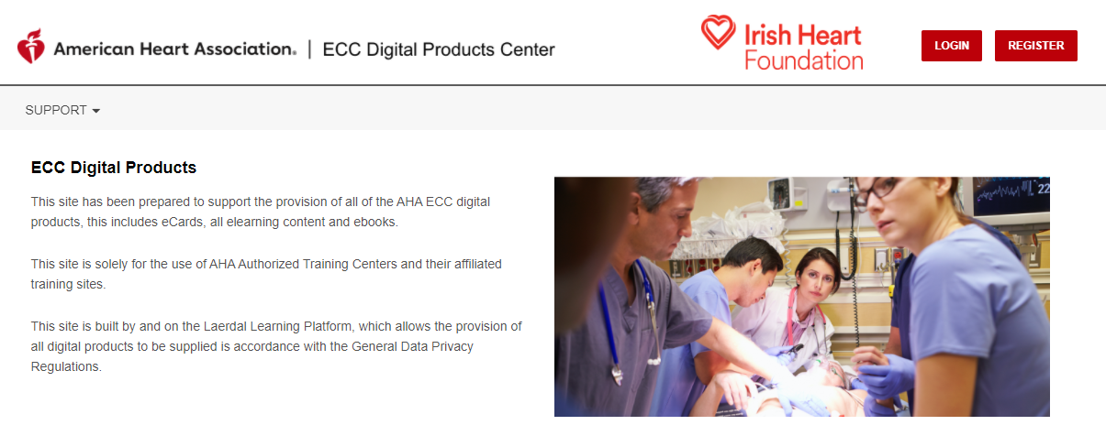

When you have accessed your student account, select My eBooks from the menu on the left

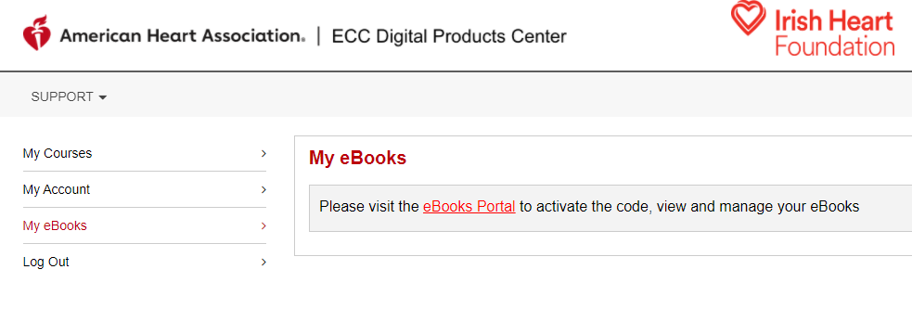

Select eBooks Portal, this will open up a separate tab for https://eu.ebooks.laerdal.com/.

In the top left corner, please enter your eBook Access Code (above)

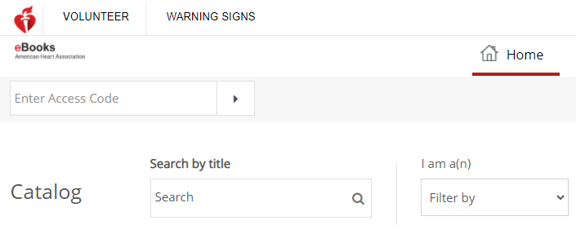

You should then be able to view your Digital eBook further down the screen.

You can also download your eBook to use offline using the Reader App – please select Download Reader App from the top right corner. eBooks will work on laptops and mobile devices. Please note - once you activate your eBook, you can download it onto a maximum of three devices for offline use.
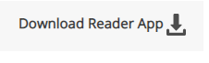

You will be able to view all your eBooks and Digital Videos using the Shelf option in the top menu.
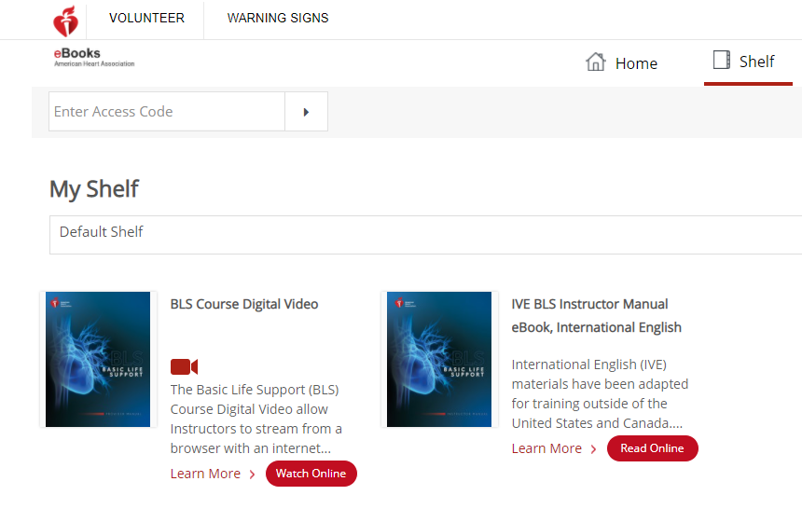

To access your materials anytime after activating your Book, login at https://ihf.eu.learning.laerdal.com/ and open up My eBooks.

