Dear Student,

You have been assigned a code to access an AHA Digital Video, <Insert relevant Access URL/ Code>

Please ensure you read the Fair Processing Notice below in regard to the use of the data you will be entering.

Fair Processing Notice: By completing registration on the Learning Portal through the above link you agree to the Irish Heart Foundation retaining your details on this secure platform for up to 5 years after the date of registration. The information will be used to contact you in relation to your digital videos. Anonymous statistical data in relation to this programme may be shared with our programme partners, American Heart Association and Laerdal Medical, for reporting and analysis purposes. If you have any requests concerning your personal information or any queries with regard to our processing, please contact resus@irishheart.ie.

Please note - once you activate your Digital Video, you can download it onto a maximum of three devices.

To access this Digital Video, please open up https://ihf.eu.learning.laerdal.com/ on your browser. If have already created an account on the Learning Platform, please Log In using your account details. If you do not already have an account set up, you will need to Register in order to activate and access your Digital Video.

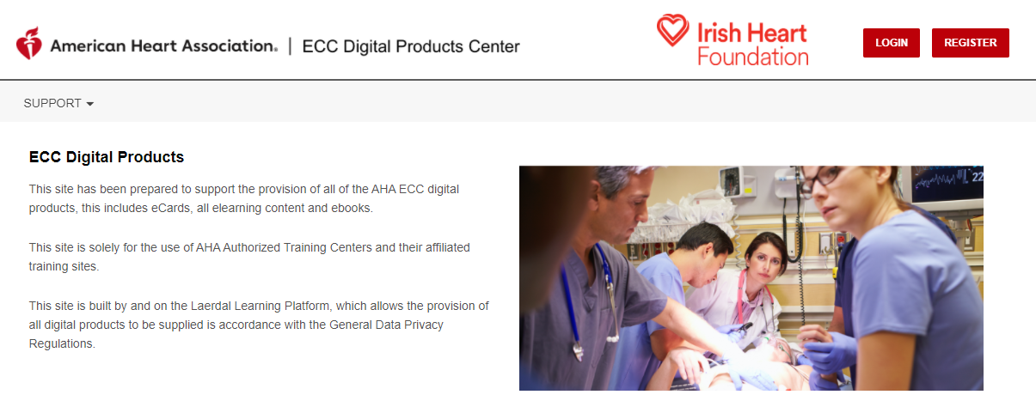

When you have accessed your student account, select My eBooks from the menu on the left

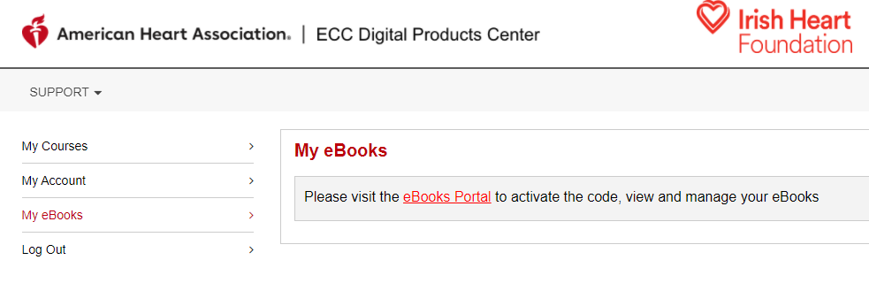

Select eBooks Portal, this will open up a separate tab for https://eu.ebooks.laerdal.com/.

In the top left corner, please enter your Digital Video Access Code (above)

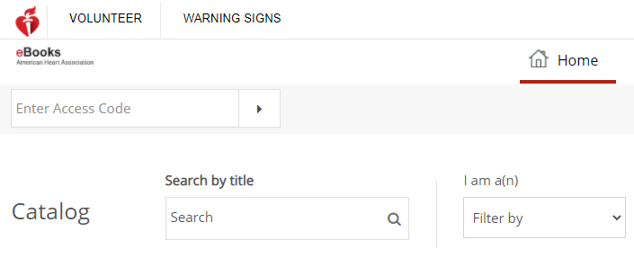

You should then be able to view your Digital Video.

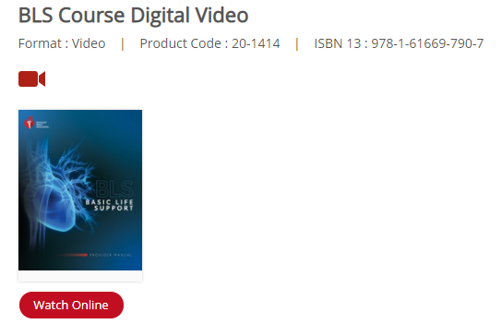

You can also download your Digital Video to use offline using the Reader App – please select Download Reader App from the top right corner. Digital Videos will work on laptops and mobile devices. Please note - once you activate your Digital Video, you can download it onto a maximum of three devices.
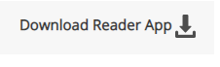

You will be able to view all your eBooks and Digital Videos using the Shelf option in the top menu.

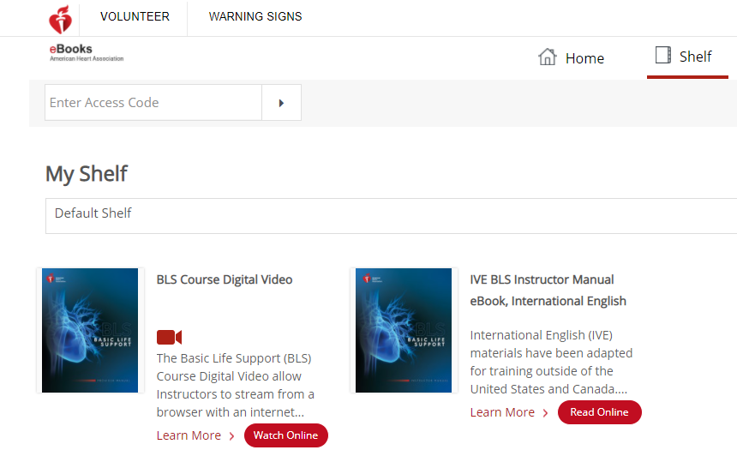

To access your materials anytime after activating, login at https://ihf.eu.learning.laerdal.com/ and open up My eBooks.

